The Ruby Murray “Heritage Trail” in Belfast

Gerald Lawrence, 11th January 2006

Just to be clear, there is no such thing officially, of course, but during a visit to Northern Ireland during the summer of 2005, two relatives of my wife (who was born in Belfast) offered to take me to the areas of Ruby’s childhood. This is the story of that visit, together with some photographs that I took. The map shows the area just off the Donegall Road (top), and is a close-knit community of mainly terraced houses, mostly with little or no front gardens. We first approached Benburb Street, the place of Ruby’s later childhood and teenage years, and where she grew to become one of the most famous singers from Northern Ireland. We arrived at the Tate’s Avenue end, to find that the street has been blocked off from traffic access by two large iron gates. We parked there, and walked through the open pedestrian gate. |  | 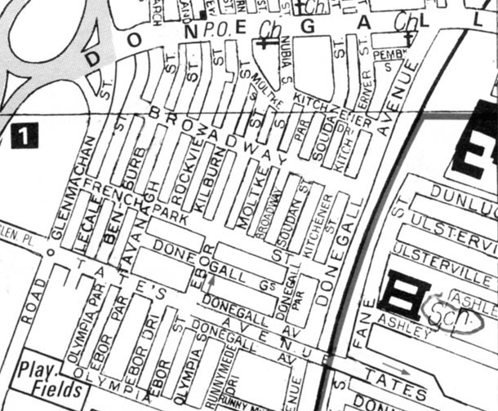
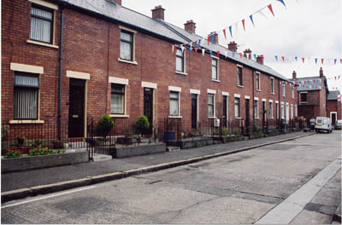 | The picture shows the side of the street with even numbers. The flags were not out for me but were part of the 12th July celebrations. This side of the road appears to be in its original form, but the odd number side had clearly been demolished and redeveloped. Ruby lived at number 49, but it seemed pointless to me to take a photograph as the house there was completely different from the other side of the road. However, undaunted by this, my wife’s aunt marched up to the front door and knocked on it. It was answered by a nice lady, who listened to why we were there, and told us that her house had indeed been rebuilt, so that the numbers were no longer in the same place as before. Some were houses and some were bungalows. She then invited her mother to come to the door, as she had lived in Benburb street all her life.
This very nice older lady then appeared, and told us that she knew Ruby when she was younger, and had gone to school with her. We chatted for a few minutes, and then she agreed to have her photograph taken at the door of the new number 49. She also gave us directions to Moltick Street, where Ruby was born, and where she had lived until she was about 7 years old. We went along Benburb street and turned right into Broadway, following the directions. But what we found was not “Moltick” Street, but Moltke Street. It seems this is the correct spelling, even though the locals pronounce it “Moltick”. We soon found number 84. |  |  | 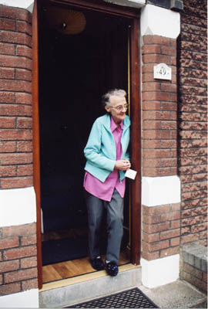

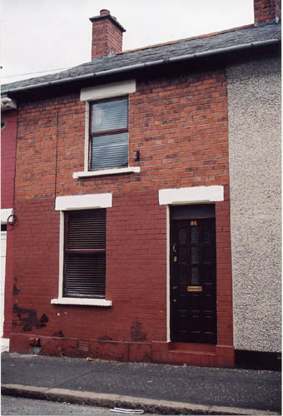 | It is clear that the houses here are a little more modest than those in Benburb Street, which accounts for why the Murray family moved there some years after Ruby was born. There was nobody present at number 84, but the lady living next door to the right came out to ask if she could help us. She had not known the Murray family, so there was not much she could add to the Ruby story, but she told us how to get to the school which Ruby attended, in Fane Street. We continued along Moltke Street, turned left and then right into Donegall Avenue until we came to some steps that took us up to the higher level of Tate’s Avenue. This was the only road in the area that crossed over the railway tracks that are between the community and Fane Street. Descending the steps on the other side, we walked along Fane Street until we came to the school entrance. It seemed rather a long and roundabout way for a young schoolgirl to go to get to school, and looking along the railway line we did see a footbridge. However, we did not use it, and we don’t know if it was there in Ruby’s time or not.
This is the main entrance to Fane Street school. The building extends a long way to the front of Fane Street, and equally as long down the side road. It is of single storey construction, and clearly hasn’t been changed externally since it was built.  We then returned to the car, and drove to see the Ulster Hall. |  |  | 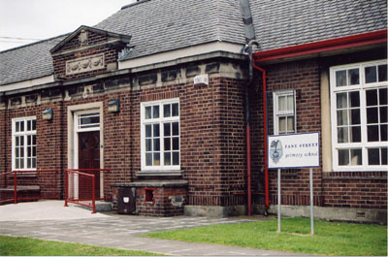
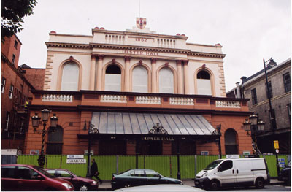 |  | The Hall was fenced off, as there were many workmen still there at that time carrying out the renovations. It appeared that the upper part of the outside was finished. While I was taking this photograph, my wife’s aunt went inside the gate, and emerged with permission for us to go inside!
Even though they were only part way through the refurbishment of the inside, it was clear that this is a beautiful hall. The high windows and the balcony seating ran all round the hall, giving the impression of a huge assembly room. To the rear is a very large pipe organ, that during our visit was covered in plastic sheeting to protect it from dust. The renovation consisted of renewing the electric cables, the heating, and checking that the pillars supporting the balcony were not corroding at the base. After this, a new coat of paint was to be applied.  The stage was not at all remote from the audience. It was very easy to imagine Ruby as a teenager coming down the steps and getting a tremendous reception from an enthusiastic audience listening to that lovely voice of hers. |  |  |  | 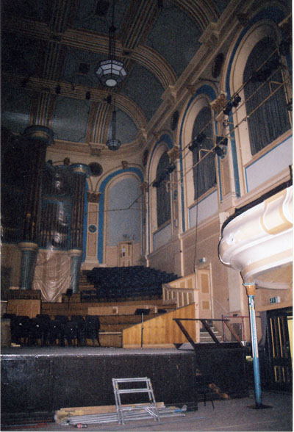

This ended our short visit to the area where Ruby lived as a youngster. Although I had my camera with me all the time, I made certain before taking any pictures that the people around me did not mind me doing so. I told them that it was for a small article to appear on the Ruby Murray website, and they readily agreed. If anyone else pays a visit to this area, then I would strongly urge them to do the same, so that no bad feelings might be generated.

